Title: Bridging East and West
Brian MacWhinney
Department of Psychology
Carnegie Mellon University, Pittsburgh
macw@cmu.edu

Encounters with Professor Chao
My first encounter with Professor Chao was back in 1973 when I was finishing up work on my PhD thesis at Berkeley. My wife Mary, who loves cookbooks, had been reading How to Cook and Eat in Chinese by his wife Yang Buwei. The introduction to the book explains how to make scrambled eggs, which Yang calls "stirred eggs". The process is described in excruciating detail, in accord with how she says her husband the linguist Yuen Ren Chao would describe the details of Mandarin grammar. It was as if he were describing in detail the movements of the tongue and jaw to produce the affricates in a variety of Chinese dialects. A bit later, I enjoyed his diary study of his granddaughter's learning of Chinese (Yuen Ren Chao, 1951) which was then the only available report on the learning of Mandarin. My next encounter was when I was learning a bit of Mandarin and had to work through the poem titled Lion-Eating Poet in the Stone Den with its continual repetition of the syllable "shi".
However, my most extensive encounter with Professor Chao was when I found myself confronted with the task of building a Mandarin morphological analyzer for the transcripts that we had collected in the CHILDES (Child Language Data Exchange System) database. At first I relied on Li and Thompson's functional grammar (Li & Thompson, 1989) for clear explanations of patterns, but when I needed fuller detail about specific morphological features, parts of speech, and alternative constructions, I inevitably turned to Chao's masterful grammar of Mandarin (Y. R. Chao, 1968) which provided full detail on every necessary feature of the language, although sometimes it did feel like "stirring eggs".
As I learned more about Professor Chao's remarkable life story, I began to realize how delighted he would be with the advances we have been making both in China and the West for improving Chinese language learning, Chinese grammatical analysis, and the study of Chinese child language -- all topics near and dear to his heart. I believe he would be particularly happy to learn about the new ways we have developed for the creation of spoken language corpora linked to digitized audio and the ways in which we are now using the Internet to share these data across the wider scholarly community. In this contribution to the Festscrift for Professor Chao, I will explain how these new systems are working and the ways in which they are now fulfilling and expanding Professor Chao's visions.

The Pinyin Tutor
I think that Professor Chao would have been delighted to see how we have begun to use online methods to help learners master the sounds of Chinese. To do this, we constructed an open-access platform called the Pinyin Tutor available from links at https://sla.talkbank.org, along with other language learning tutors for German, Spanish, and English. The Pinyin Tutor for Mandarin and its cousin the Jyutping Tutor for Cantonese present the sounds of words and phrases and the student is then asked to write out the Pinyin for each sound. If the student’s response is correct, the tutor moves on to the next form. If it is incorrect, the system provides precise feedback on which segments or tones are right and which are wrong. Students can also ask the computer to play the sound corresponding to what they had typed in. Each student’s responses are scored in a database that uses the method of extended interval recall to focus new trials on forms that are not yet learned. As a given level is mastered, the system moves on to progressively longer and more difficult forms. The system works both within a computer browser and through an app from the App Store or Google Play. Figure 1 shows how this looks on an iPhone and it also shows the upper left corner of the chart of Pinyin forms of possible Mandarin syllables, each of which can be clicked to play back the sound with various tones. Professor Chao related how quickly Edward Sapir was able to master the tones of various Chinese dialects. Perhaps he would have been able to also sail through the Pinyin Tutor, particularly if it had used Chao’s Gwoyeu Romatzyh instead of Pinyin.
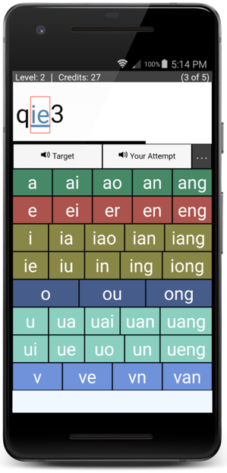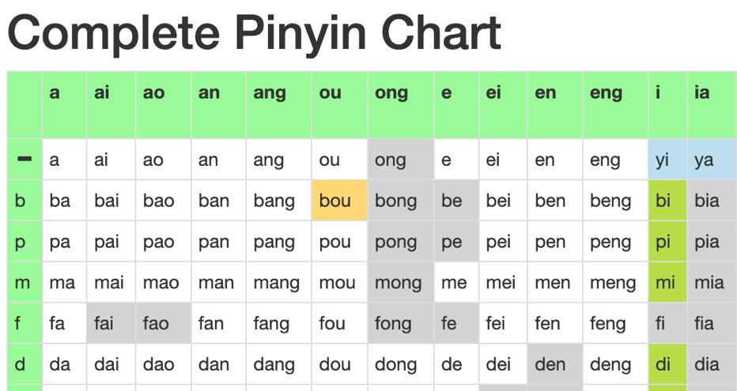
Figure 1: The Pinyin Tutor interface and a fragment of the clickable Pinyin Chart

TalkBank
Advances in computer technology have produced a flood of new data sets for understanding human language (Goldstone & Lupyan, 2016). However, nearly all these new datasets are based on written, rather than spoken, language. The TalkBank system (http://talkbank.org) is the world’s largest open-access integrated repository for spoken language data. It provides language transcripts, media, and resources to support researchers in Psychology, Linguistics, Education, Computer Science, and Speech Pathology. There are now over 12,000 articles based on the use of TalkBank data and programs. The system emphasizes Open Science principles by making its data, programs, and tools free and easily accessible. It provides data from 47 languages across 15 content areas. It would have pleased Professor Chao to find that there is a particularly strong representation of data from both East Asia and the West, helping to solidify the East-West bridge that he promulgated. These corpora have been contributed by hundreds of researchers, all using a common transcription format called CHAT. The use of this common format is a unique feature of TalkBank that has allowed us to construct an innovative set of resources and tools for analyses across languages, corpora, and speakers. This review describes these resources and some of the many analyses they have supported.

TalkBank Databases
TalkBank includes 35GB of transcript data and 12TB of media data, all served across the web from the Carnegie Mellon University Campus Cloud facility. Links to each of these 15 TalkBank databases can be found at https://talkbank.org. They include:
- AphasiaBank for the study of language in aphasia,
- CHILDES (CHIld Language Data Exchange System) with data from 47 languages from language-learning children between infancy and age 6,
- FluencyBank for the study of language fluency and disfluency in stuttering, aphasia, second language learning, and normal processing,
- HomeBank for the study of daylong recordings in the home and elsewhere,
- PhonBank for the analysis of phonological development in 18 languages,
- ASDBank for child language in autism spectrum disorder (ASD),
- BilingBank for the study of adult bilingualism and multilingualism,
- CABank for the study of adult conversation often using the methods of Conversation Analysis,
- ClassBank for the study of language in the classroom,
- DementiaBank for the study of language in dementia,
- PsychosisBank for the study of language in psychosis,
- RHDBank for the study of language in right hemisphere disorder (RHD),
- SamtaleBank for the study of conversations in Danish,
- SLABank for the study of second language acquisition (SLA), and
- TBIBank for the study of language in traumatic brain injury (TBI).
Professor Chao would be pleased to know that six of these databases include data from Chinese languages, including Mandarin, Cantonese, Minnan, and Hakka.
1. AphasiaBank has an excellent corpus of data from 9 Mandarin-speaking persons with aphasia (PWAs) and 35 control participants all providing data using the AphasiaBank protocol which maximizes the ability to make comparisons across languages. This corpus has transcripts linked to video that allow users to follow through the interactions directly in the TalkBank Browser (see below). The corpus was developed by Zhongli Jiang and Feng Lin of the Nanjing Medical University Hospital. There is also an older transcript-only corpus of picture descriptions by Mandarin-speaking PWAs that was part of the crosslinguistic aphasia project from Elizabeth Bates and colleagues (Bates, Chen, Tzeng, Li, & Opie, 1991).
2. The CHILDES database is rich with data from Chinese languages with two major corpora from Cantonese and 19 from Mandarin. Eight of these corpora are linked to audio and one (Tong) is linked to video. In addition to these corpora from monolingual acquisition, there are four corpora from 9 English-Cantonese bilinguals and two English-Cantonese-Mandarin trilinguals contributed by Virginia Yip and Stephen Matthews.
3. PhonBank has a large Minnan child language corpus with full phonological annotation from Jane Tsay and a corpus on Cantonese phonology from the Paidologos project (Chung et al., 2012).
4. CABank has two sets of phone calls in Mandarin. One is in the CallHome collection of people calling from the States back to China and the other is in the CallFriend collection of Chinese people in the States calling their friends in the States.
5. DementiaBank has two corpora of Mandarin data. One is naming data from people with Parkinson's and some mild cognitive impairment from Zheng Yi of the Institute of Neuroscience in Shanghai. The other is semantic fluency data from Ching-ching Lu at National Tsinghua in Taiwan.
6. SLABank has two sets of audio data with linked transcripts from students in universities in Hong Kong learning Mandarin. One is from Yanhui Zhang at Chinese University and the other from Angel Chan at Hong Kong Polytechnic.

TB Browser
All of these data can be accessed directly online without any downloading by using the TalkBank Browser (TBB). TBB uses a custom-made browser that allows users to navigate through the corpora and transcripts to play back media continuously while each line is highlighted in the transcript. Figure 2 illustrates how this looks for a transcript from the Mandarin corpus in AphasiaBank. The left side of the screen includes the transcript navigator, the video display, and a window for running analysis programs. The video display can be repositioned and enlarged for clearer viewing. The top of the window summarizes information about the currently selected transcript and the lower part of the window provides utterances for playback.
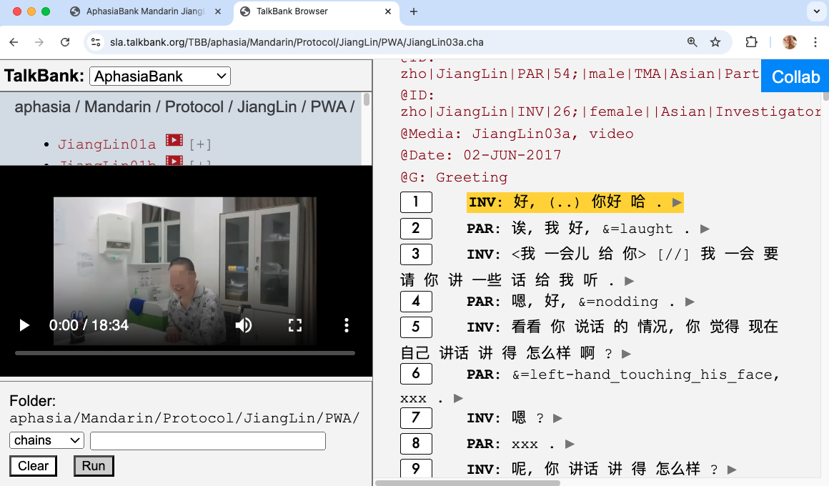
Figure 2: The TalkBank Browser window for one sample in the Mandarin AphasiaBank corpus

Collaborative Commentary
In the upper right corner of Figure 2 there is a little blue button labelled "Collab”. Clicking on this button opens a facility called Collaborative Commentary (CC) which allows groups to analyze spoken interactions collaboratively, often guided by a coding system. Figure 3 illustrates how students in a senior-level university class in Psycholinguistics coded the second utterance in the biggirl.cha transcript from the case study by Michael Forrester in CHILDES.
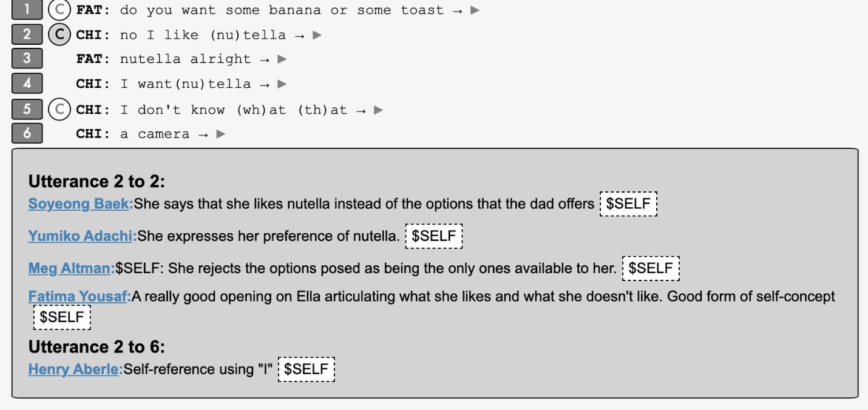
Figure 3: A single utterance coded in Collaborative Commentary
Using one of the 14 codes that had been established by the instructor, the students uniformly coded this utterance as serving to express the child's self-concept ($SELF) in regard to food preferences. The codes were all combined with further comments. Codings and comments like these are stored in a database separate from the main transcript database. The instructor can also click on any student comment to send an email message providing feedback to the student who created the comment.
Collaborative Commentary is being used actively by research groups interested in developing new modes of transcript analysis. For example the researchers participating in the APT (Academically Productive Talk) project at https://class.talkbank.org/access/APT.html are using Collaborative Commentary to code methods for producing academically productive talk (APT) in classroom interactions (Al-Adeimi & O'Connor, 2021) across 51 videotaped classroom sessions in grades K-11. The resultant coding decisions are then evaluated for reliability to determine strengths and weaknesses in the APT coding system and its underlying theoretical framework.

TalkBankDB
The TalkBank Database (TBDB) allows users to search for strings and patterns within or across all the transcripts in the 15 TalkBank databases. Using search patterns inserted into dialog boxes, users can retrieve segments of text based on participants, utterances, tokens, types, sequences of types, sequences of tokens, or n-grams. Queries can focus on specific files, specific corpora, or collections of files and corpora. Participants can be selected in terms of their role (Child, Investigator, Mother, etc.), age group, gender, clinical type, social status, or experimental condition. Searches can target specific words, combinations of words, codes, parts of speech, phonological structures, and grammatical dependency relations. The utterances and words that are matched can be downloaded to the user’s local machine for further statistical analysis or further analyzed on the web. An alternative method for interacting with TBDB is to use one of the APIs (application programming interfaces) made available for R and Python.

Programs and Tutorials
The CLAN program is used to analyze TalkBank data on the desktop. It can be downloaded from https://dali.talkbank.org and the manual is available at https://talkbank.org/manuals/CLAN.pdf. Tutorial screencasts at https://talkbank.org/screencasts explain how to transcribe in CHAT and how to use CLAN programs, Collaborative Commentary, the TalkBank Browser, and TalkBankDB.
CLAN includes an editor with commands like those in MS-Word along with features for linking to media and for marking spoken language features. It provides 24 commands for different types of corpus analysis, 10 commands that run packages for language profiling analyses, 17 format conversion commands, and 20 format modification commands.
The CHAT format is also supported by the Phon program at https://phon.ca which has been used to create the PhonBank database. Both Phon and PhonBank have been built by Yvan Rose and Greg Hedlund at Memorial University Newfoundland. Phon provides extensive support for detailed analysis of both child and adult phonological structures and development, including automatic IPA coding, full integration of the Praat phonological analysis system (Boersma, 2001), packages for standard phonological assessments, and methods for examining interactions between segments, syllables, words, and grammatical structures. A transcript created by the CLAN editor can be opened directly in Phon and vice versa.

Batchalign
Batchalign2 (Liu, MacWhinney, Fromm, & Lanzi, 2023) which can be downloaded from https://github.com/talkbank /batchalign2 is a Python program with three basic functions designed to support creation of TalkBank corpora.
1. Batchalign2 can use automatic speech recognition (ASR) to generate a CHAT transcript from either audio or video media. This function can either send audio over the web to the Rev-AI transcription service or use the OpenAI Whisper ASR model locally, because the Batchalign2 installation includes a download of the Whisper model. For English, we have found that both systems work well for two-party conversations recorded in good acoustic environments. Using a benchmarking program built into Batchalign, we have found a word error rate (WER) for Rev-AI that ranges from 1% for well-recorded TED speeches and two-party interviews to 20% for recordings in poorer audio conditions from people who stutter. However, Rev-AI does not yet support Chinese languages, so only Whisper can be used.
2. The second function of Batchalign2 is to automatically analyze CHAT transcripts for morphosyntactic structure. To do this, it relies on neural network models from the Stanza system (Qi, Zhang, Zhang, Bolton, & Manning, 2020) trained with data from 70 language treebanks in the Universal Dependencies project (De Marneffe, Manning, Nivre, & Zeman, 2021). Liu and MacWhinney (2024) report on the use of UD in Batchalign to analyze CHILDES data in 27 languages in terms of parts-of-speech (POS), lexical features, and grammatical relations (GRs). For English, the output of this process is very accurate. An analysis by Liu and MacWhinney of Batchalign UD output for 7170 words in the Sarah transcripts in the Brown (1973) corpus found only one error type impacting three words. The accuracy of tagging for other languages requires judgments from native speaker linguists. Accuracy for Mandarin is good, because the model was trained on a large corpus. However, the training corpus for Cantonese is rather small, leading to a lesser accuracy.
3. The third function of Batchalign2 is to automatically align a CHAT transcript with media. Prior to the creation of Batchalign2, alignment of transcripts to media required the researcher to play through a transcript line by line while listening to the audio and hitting the space bar at the end of each utterance. Batchalign2 automates this process by re-running ASR and using that output as a backplate for probabilistic alignment of utterance groups or batches. This method works nearly perfectly if the utterances in the transcript are in the correct order. Moreover, the output includes begin-end time marks for both utterances and individual words.

Applications
TalkBank data and programs have been used to address a wide range of issues in language learning, processing, disorders and usage. Summarizing the work in over 12,000 published articles is beyond the scope of this report, but we can mention a few illustrative projects from some of the 15 components of TalkBank. For each of these, we hope that researchers in China could perform similar analyses with Chinese speakers.
- Computer scientists have used DementiaBank data in three INTERSPEECH challenges to predict the onset of MCI (mild cognitive impairment) based on analyses of acoustic, lexical, and grammatical aspects of recordings and transcripts of picture descriptions (Luz, Haider, de la Fuente Garcia, Fromm, & MacWhinney, 2021). This work mostly uses the Pitt Corpus which contains a sentence repetition task and descriptions of the Cookie Theft picture from 270 participants with MCI and 140 control participants. The core task is to classify samples as either MCI/AD, or control. The systems used to address this task include a variety of ML (Machine Learning) and AI (Artificial Intelligence) methods. Earlier approaches to AD recognition through speech used different, often unbalanced and acoustically varied data sets, consequently hindering reproducibility and comparability of approaches. The three INTERSPEECH challenges have provided a forum for scores of academic and commercial research groups to test their existing methods or to develop novel approaches on a new shared standardized dataset, resulting in over 100 published articles. The most recent TAUKADIAL challenge included both English and Mandarin samples to test the robustness of algorithms across languages.
- In parallel with this extensive work on AD detection, there have been 87 published articles applying ML and AI methods to the task of improving ASR (automatic speech recognition) for the speech of people with language disorders. This work has been based on training data from AphasiaBank, DementiaBank, and FluencyBank (for stuttering), as well as data in CHILDES from children speaking non-mainstream dialects.
- Using videos from AphasiaBank, researchers have shown how gesture substitutes for speech, particularly in nonfluent Broca’s aphasia (van Nispen, van de Sandt-Koenderman, Sekine, Krahmer, & Rose, 2017). In these videos, participants with aphasia describe the story of Cinderella after having reviewed a wordless picture book version. Because nonfluent aphasia is often accompanied by word finding difficulties, participants make use of gestures as substitutes for the words they cannot find, thereby showing that they know the object or action, even if they cannot find the word.
- During the first stages of language learning, children fail to mark tense on the finite verb (the main verb of a simple clause). Wexler (1994) proposed that this failure is due to a delayed maturation of an innate universal constraint that requires this marking. However, Freudenthal, Pine, Aguado-Orea, and Gobet (2007) showed that the level of use of non-finite (infinitive or infinitival) forms across four languages in the CHILDES database aligned closely with language variation in the input, rather than with a universal maturational constraint.
- Using ClassBank videos from a 14-day program of lessons in a 2nd grade classroom, Strom et al. (2001) were able create a dynamic flow chart of developing understandings of area and symmetry in geometric patterns. To capture this advancing understanding, they created three concept graphs to illustrate the children’s successive formulations of 13 procedures for measuring area, 5 levels of congruence tests, and 4 principles derived from earlier work on symmetry and area in quilt design, along with the relations between these knowledge components. Each of these 22 knowledge components was then linked to specific utterances in the ClassBank video transcript. Taken together, this analysis shows how classroom instruction with specific geometric examples can produce a richer network of geometric understandings and how this development can be studied developmentally.
- Anderson and Schooler (1991) used data from a subsection of CHILDES to test the claim that “the probability that a memory will be needed shows reliable relationships to frequency, recency, and pattern of prior exposures” as evidenced in parental input to language-learning children. They modelled this relation in terms of the retention function, the practice function, and the spacing effect.
- Using transcript data from CHILDES, Karniol (2010) developed a book-length analysis of social development as preference management, which she rephrases in the title of the book as “how infants, children, and parents get what they want from one another.” Her analysis deals with issues such as temporizing preferences, disciplining noncompliance, coping and self-regulating, and parental channeling of child preferences. The development of each these aspects of social development, as well as several others, is illustrated through specific verbal interactions from CHILDES and similar sources.
- Eppler, Luescher, and Deuchar (2017) used data from code-switched interactions in the Eppler corpus in BilingBank to test the predictions of three syntactic theories - the Minimalist Program (MP), Word Grammar (WG), and the Matrix Language Frame Model (MLF) – in terms of their ability to predict grammatical feature agreement between determiners and nouns. Examples of combinations in which features do not agree between the languages stand as failures for each of the theories. For example, the phrase alle bus (all buses) instead of alle buses has a plural German determiner with a singular English noun and this combination is not predicted by these models.
- Using corpora from 56 university learners majoring in French in SLABank, McManus, Mitchell, and Tracy-Ventura (2021) followed the progression of the language skills of complexity, accuracy, lexicon, and fluency (CALF) across 3 years to assess patterns of L2 learning, maintenance, and attrition. Results showed ongoing improvements on most measures, including accuracy. There were long-term relationships between fluency and vocabulary, but relationships involving accuracy and complexity emerged only in instructed contexts.
- Using data from daylong recordings in the home in the Cougar corpus in HomeBank, Kondaurova, VanDam, Zheng, and Welikson (2023) found that mothers increased their vocal pitch when speaking with toddlers, as opposed to when they were speaking with other adults. This effect has been interpreted as a way for mothers to provide emotional support for their children. However, fathers did not show the same increase in pitch when speaking with toddlers. The absence of this pitch adjustment in fathers supports the view formulated in Gleason’s (Gleason, 1975) Bridge Hypothesis according to which fathers provide young children with challenges that allow them to interact with an increasingly wider range of adults.
- LaSalle and Wolk (2023) used transcripts from 43 children across five corpora in FluencyBank to examine the effects of parental responses to utterances in which the child stutters. If the parent’s response involved recasting, then the following child utterance contained significantly less stuttering than if the parent’s response did not involve recasting. This was interpreted as showing that parental recasting served to facilitate children’s fluency, perhaps by providing clear lexical and grammatical forms that chidllren could use in further productions. However, this difference between recasting and non-recasting responses did not obtain for 9 of the 43 children who had persistent stuttering. The lack of a positive effect for this group could be due to co-morbidity with phonological disorders or perhaps their heightened emotional reaction against recasting and correction.

Future Directions
A major challenge going forward is to expand and broaden the Chinese TalkBank databases in ways that will support analyses of the types described above. By doing this we can integrate Chinese studies into these five goals for the future:
- We want to make maximal use of the many new tools offered by new developments in AI (Artificial Intelligence) and ML (Machine Learning) to improve language data collection, transcription, and analysis. It will be particularly important to improve the model training resources for Mandarin and Cantonese to provide better analyses for these two languages.
- We want to extend the crosslinguistic coverage of TalkBank, not only for Mandarin, but also for other Chinese dialects.
- A great strength of the CHILDES database is the longitudinal nature of many of the corpora which track child language development across as much as five years. We need data with a similar longitudinal design for the study of areas such as dementia, recovery from strokes in aphasia, and second language learning – all with Chinese speakers.
- Many current analyses examine single dimensions of language learning and production, such as lexicon, grammar, conversation, phonology, accuracy, fluency, or complexity. We are developing new methods in TalkBankDB that will allow us to track patterns and interactions across all of these systems.
- In the first 10 months of its availability, instructors, clinicians, and researchers have generated 12,652 comments using Collaborative Commentary. Going forward, we want to work with specific projects and classes, including those in China, to develop and test new methods of using the commentary database to test hypotheses and coding systems.

Conclusion
The Pinyin Tutor and TalkBank implement different versions of Professor Chao's views for the future of language studies. The Pinyin Tutor demonstrates how online instruction can facilitate learning of difficult aspects of Chinese. TalkBank has made major empirical contributions to research in Developmental Psychology, Cognitive Psychology, Psycholinguistics, Linguistics, Conversation Analysis, Second Language Acquisition, Education, Clinical Linguistics, Speech and Hearing, Natural Language Processing, and Computer Science. These contributions represent a commitment to the principles of data-sharing, Open Science, replicability, and use of a consistent data format. These principles are in line with the principles exemplified in the work and contributions of Professor Yuen Ren Chao.

Recommended Reading
Goldstone, R., & Lupyan, G. (2016). Discovering psychological principles by mining naturally occurring data sets. Topics in Cognitive Science, 8, 548-568. https://doi.org/10.1111/tops.12212
Liu, H., & MacWhinney, B. (2024). Morphosyntactic analysis for CHILDES. Language Development Research, 4(1), 233-258. https://doi.org/10.34842/j97r-n823
MacWhinney, B., & Fromm, D. (2023). Collaborative commentary for understanding communication disorders. American Journal of Speech-Language Pathology, 32(5S), 2580-2588. https://doi.org/10.1044/2023_AJSLP-22-00385

Acknowledgements
The development of CHILDES and HomeBank is supported by NICHD grant HD082736. The development of DementiaBank is supported by NIA Grant RF1AG083823. The development of PhonBank is supported by NICHD grant HD051698. The development of AphasiaBank is supported by NIDCD grant DC008524. The development of FluencyBank was supported by NIDCD grant DC015494. The development of TalkBankDB and the authentication system was supported by NIH ODSS FAIR and TRUST supplement grants HD082736-18S1 and HD082736-18S2. The creation of Collaborative Commentary was supported by NSF HNDS grant BCS2117578.

References
Al-Adeimi, S., & O'Connor, C. (2021). Exploring the relationship between dialogic teacher talk and students’ persuasive writing. Learning and Instruction, 71, 101388.
Anderson, J., & Schooler, L. (1991). Reflections of the environment in memory. Psychological Science, 2, 396-408.
Bates, E., Chen, S., Tzeng, O., Li, P., & Opie, M. (1991). The noun-verb problem in Chinese aphasia. Brain and Language, 41, 203-233.
Boersma, P. (2001). Praat: doing phonetics by computer. Retrieved from https://www.praat.org. https://www.praat.org
Brown, R. (1973). A first language: The early stages. Cambridge, MA: Harvard University Press.
Chao, Y. R. (1951). The Cantian ideolect: An analysis of the Chinese spoken by a twenty-eight-months-old child. University of California Publications in Semitic Philolology, 1, 27-44.
Chao, Y. R. (1968). A grammar of spoken Chinese. Berkeley, CA: University of California Press.
Chung, H., Kong, E. J., Edwards, J., Weismer, G., Fourakis, M., & Hwang, Y. (2012). Cross-linguistic studies of children’s and adults’ vowel spaces. The Journal of the Acoustical Society of America, 131(1), 442-454.
De Marneffe, M.-C., Manning, C. D., Nivre, J., & Zeman, D. (2021). Universal dependencies. Computational Linguistics, 47(2), 255-308.
Eppler, E. D., Luescher, A., & Deuchar, M. (2017). Evaluating the predictions of three syntactic frameworks for mixed determiner–noun constructions. Corpus Linguistics and Linguistic Theory, 13(1), 27-63.
Freudenthal, D., Pine, J. M., Aguado‐Orea, J., & Gobet, F. (2007). Modeling the developmental patterning of finiteness marking in English, Dutch, German, and Spanish using MOSAIC. Cognitive Science, 31(2), 311-341.
Gleason, J. B. (1975). Fathers and other strangers: Men’s speech to young children. Developmental psycholinguistics: Theory and applications, 1, 289-297.
Goldstone, R., & Lupyan, G. (2016). Discovering psychological principles by mining naturally occurring data sets. Topics in Cognitive Science, 8, 548-568. doi:10.1111/tops.12212
Karniol, R. (2010). Social development as preference management: How infants, children, and parents get what they want from one another: Cambridge University Press.
Kondaurova, M. V., VanDam, M., Zheng, Q., & Welikson, B. (2023). Fathers’ unmodulated prosody in child-directed speech. The Journal of the Acoustical Society of America, 154(6), 3556-3567.
LaSalle, L., & Wolk, L. (2023). Adult recasts as fluency-facilitators in preschoolers who stutter: Evidence from FluencyBank. Journal of Fluency Disorders, 76, 105971.
Li, C. N., & Thompson, S. A. (1989). Mandarin Chinese: A functional reference grammar: Univ of California Press.
Liu, H., & MacWhinney, B. (2024). Morphosyntactic analysis for CHILDES. Language Development Research, 4(1), 233-258. doi:10.34842/j97r-n823
Liu, H., MacWhinney, B., Fromm, D., & Lanzi, A. (2023). Automation of language sample analysis. Journal of Speech, Language, and Hearing Research, 66, 2421-2433. doi:10.1044/2023_JSLHR-22-00642
Luz, S., Haider, F., de la Fuente Garcia, S., Fromm, D., & MacWhinney, B. (2021). Editorial: Alzheimer’s dementia recognition through spontaneous speech. Frontiers in Aging Neuroscience, 3. doi:10.3389/fcomp.2021.780169
McManus, K., Mitchell, R., & Tracy-Ventura, N. (2021). A longitudinal study of advanced learners’ linguistic development before, during, and after study abroad. Applied Linguistics, 42(1), 136-163.
Qi, P., Zhang, Y., Zhang, Y., Bolton, J., & Manning, C. D. (2020). Stanza: A Python natural language processing toolkit for many human languages. Paper presented at the Proceedings of the 58th Annual Meeting of the Association for Computational Linguistics: System Demonstrations.
Strom, D., Kemeny, V., Lehrer, R., & Forman, E. (2001). Visualizing the emergent structure of children's mathematical argument. Cognitive Science, 25(5), 733-773.
van Nispen, K., van de Sandt-Koenderman, M., Sekine, K., Krahmer, E., & Rose, M. L. (2017). Part of the message comes in gesture: how people with aphasia convey information in different gesture types as compared with information in their speech. Aphasiology, 31(9), 1078-1103. doi:10.1080/02687038.2017.1301368
Wexler, K. (1994). 14 Optional infinitives, head movement and the economy of derivations¹. Verb movement, 305.

